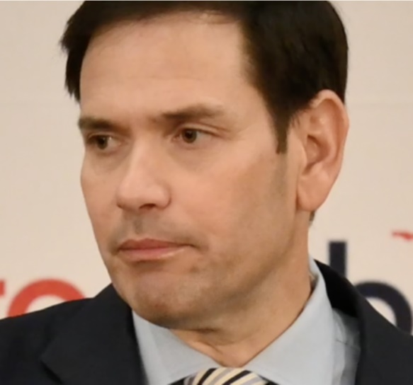
Marxism is the Single Greatest Threat to America
The Floridian Press, by GRAYSON BAKICH, SEPTEMBER 2, 2022
Sen. Marco Rubio (R-FL) gave a speech in Fort Lauderdale to 100 pastors and faith leaders this week about the threat that Marxism poses to the American way of life.
As The Floridian covered yesterday, Sen. Rubio discussed the harm "woke" culture has inflicted on American society, namely in schools and in the military. Additionally, Rubio says that the greatest threat to America overall is Marxist ideology.
Rubio admits he may be preaching to the choir to an extent when he says "and when I say this term, this is probably not a hard audience to convince," he begins.
"I think perhaps some of the people hear this elsewhere would sort of cringe at what I'm about to say, but it's the truth," said Rubio, clarifying that it is "not that outrageous in comparison, but I believe it to be a fundamental truth."
Rubio then dives into the meat of the matter.
"And that is that what now assails our country is Marxism," proclaimed Rubio. He says that most Americans are unaware of its influence on society.
"Now, let me tell you something. A lot of the people who support elements of it don't recognize it as such. Because to them, Marxism is, you know, Soviet-style, or socialism." Rubio digresses for a moment to clarify that socialism and Marxism are not the same things. "Socialism is an economic model. You can be a socialist and not be a Marxist," Rubio added.
The difference, he says, is that "Marxism is not an economic model. It is a power model." By this, he means that "and it is a model that says, "not only do we believe in this, but we will tolerate no dissent and no competition. Marxism tolerates no competition."
"So, in Marxism the schools do not work for the parents. In Marxism, the schools do not work to educate children. The schools work for the system. It works for Marxism. And they must be an element of indoctrination," added Rubio.
He continues to stress the totalitarian nature of Marxism, saying, "in Marxism, they tolerate no competition from the family. You can't have parents telling their kids one thing opposite from what we think. And so the system has to take precedence over the family and over the authority of parents."
But this does not just apply to education.
Rubio adds, "In Marxism, there can be no independent media, there can be no diversity of opinion. If you somehow are a media figure or a public figure who's speaking out against their system, you need to be silenced. You're a counter-revolutionary, you're dangerous, you're a threat."
As such, it is an unforgiving ideology.
"It knows no bounds, we make the mistake of thinking it has any limits." Moreover, our obliviousness to it is deadly. "We have made a mistake in not thinking that this is a global effort, popping up in country after country, but America would obviously be the crown jewel."
Rubio concludes, "so that word is separating people of faith. Well it brings us to a point that I predicted five or six years ago. When I said it, I encourage people standing in the back to cover this, and all those who like to do fact-checking to check it out, I said, "the day will come, when the teachings of mainstream Christianity is defined as hate speech." And that day is here. That day is here."

